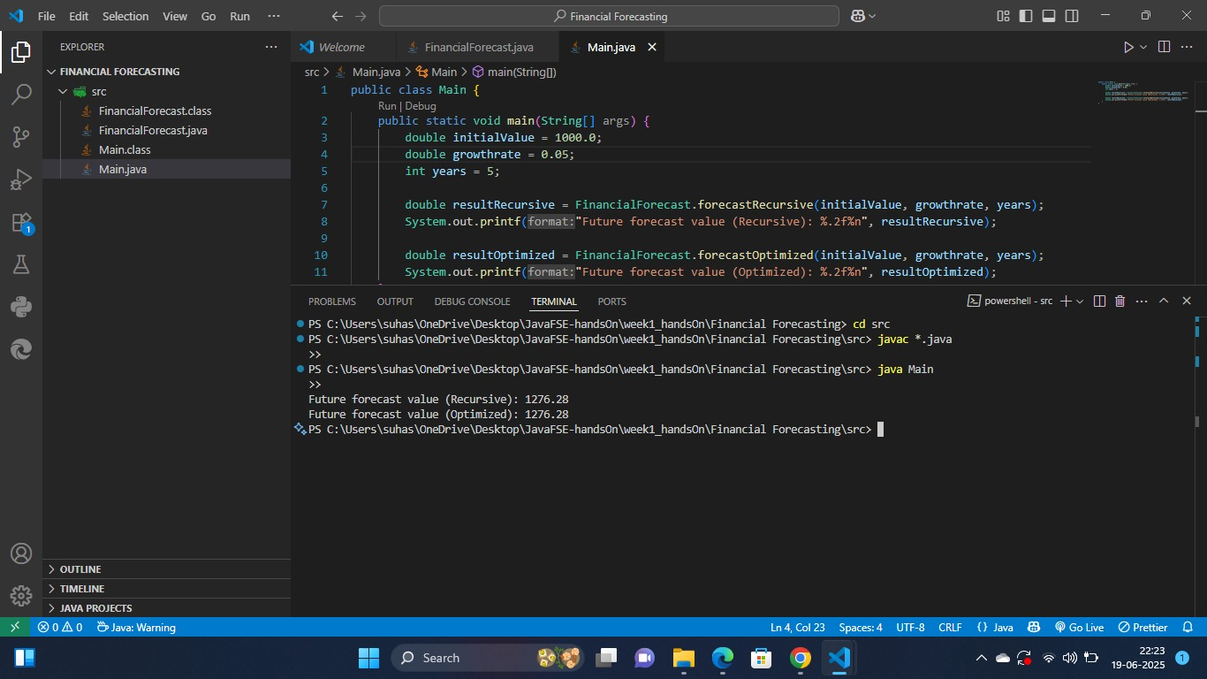Financial Forecasting (OUTPUT):